NMAP NETWORK SCANNING
Practical / Lab Record

Aim
To perform basic network scanning using Nmap in Kali Linux and observe the status of hosts and selected TCP/UDP ports.

Procedure
- Open Kali Linux and launch the Terminal.
- Enter the Nmap commands in the terminal.
- Perform a TCP SYN scan using: nmap -sS 192.168.1.1
- Perform a TCP connect scan using: nmap -sT 192.168.1.1
- Perform a TCP ACK scan using: nmap -sA 192.168.1.1
- Perform a UDP scan using: nmap -sU 192.168.1.1
- Scan selected ports using: nmap -p 22,80,443 172.29.99.181
- Observe the host status, port state, and service information shown by Nmap.
- Record the results for the practical.

Commands Used
nmap -sS 192.168.1.1
nmap -sT 192.168.1.1
nmap -sA 192.168.1.1
nmap -sU 192.168.1.1
nmap -p 22,80,443 172.29.99.181

Observed Results
For 192.168.1.1, the scans shown in the screenshots reported that the host seemed down and Nmap detected 0 hosts up. The output suggested using -Pn if the host was actually up but blocking ping probes.
For 172.29.99.181, the host was reported as up. Ports 22/tcp (SSH), 80/tcp (HTTP), and 443/tcp (HTTPS) were shown as filtered.

Screenshots / Output
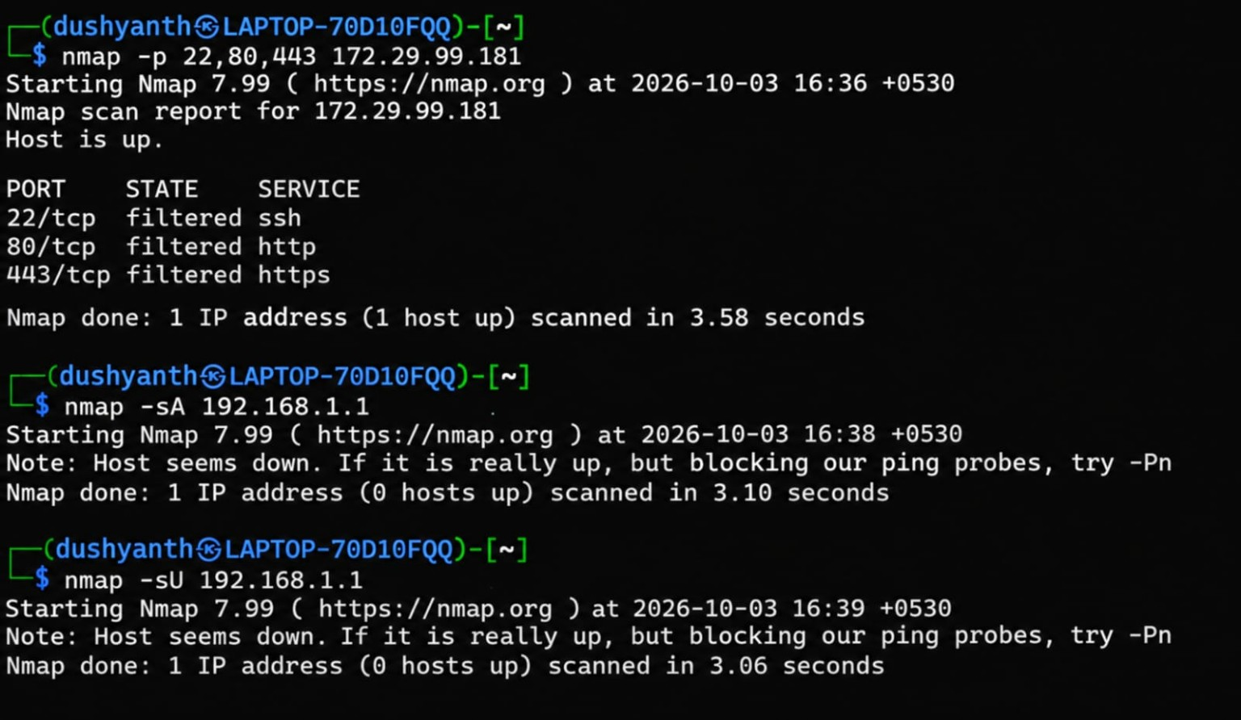
Figure 1: Nmap terminal output

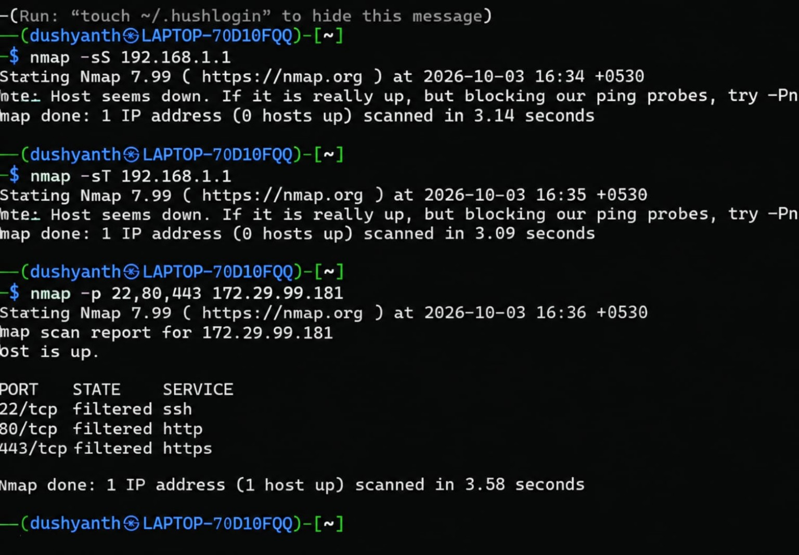
Figure 2: Nmap terminal output

Conclusion
Nmap was successfully used to perform different types of network scans. The output helped identify whether a host was reachable and showed the state and service associated with the selected ports. The practical demonstrates the basic use of Nmap for network reconnaissance in an authorized lab environment.

